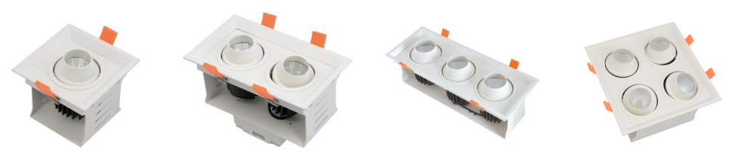

1. **Model No. GSD801**

|  |  |  |  |  |  |  |  |  |  |  |
| --- | --- | --- | --- | --- | --- | --- | --- | --- | --- | --- |
| **Model No.** | **Power** | **Lumen(lm)** | **Driver Brand** | **LED Style** | **CCT(K)** | **Beam Angle** | **Power Factor** | **CRI** | **Size(mm)** | **Cutout(mm)** |
| GSD801-1-C | 1*8W | 700lm | Philips Driver | CREE | 3000K  4000K  5000K | 15°  24° | >0.90 | Ra80/90 | 110*110*96 | 100*100 |
| GSD801-2-C | 2*8W | 2*700lm | 190*110*96 | 180*100 |
| GSD801-3-C | 3*8W | 3*700lm | 264*110*96 | 255*100 |
| GSD801-4-C | 4*8W | 4*700lm | 190*190*96 | 180*180 |

**Product Name: LED Grille Downlight 8W**

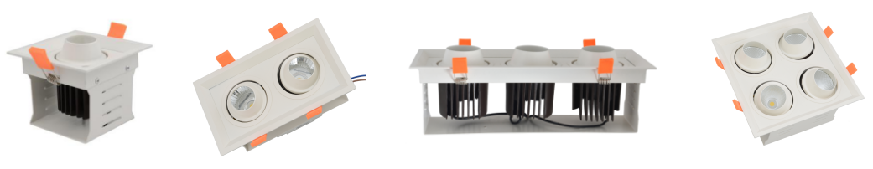

1. **Model No. GSD1201**

**Product Name: LED Grille Downlight 12W**

|  |  |  |  |  |  |  |  |  |  |  |
| --- | --- | --- | --- | --- | --- | --- | --- | --- | --- | --- |
| **Model No.** | **Power** | **Lumen(lm)** | **Driver Brand** | **LED Style** | **CCT(K)** | **Beam Angle** | **Power Factor** | **CRI** | **Size(mm)** | **Cutout(mm)** |
| GSD1201-1-C | 1*12W | 1000lm | Philips Driver | CREE | 3000K  4000K  5000K | 15°  24° | >0.90 | Ra80/90 | 132*132*121 | 120*120 |
| GSD1201-2-C | 2*12W | 2*1000lm | 232*132*121 | 220*120 |
| GSD1201-3-C | 3*12W | 3*1000lm | 340*132*121 | 330*120 |
| GSD1201-4-C | 4*12W | 4*1000lm | 232*232*121 | 220*220 |

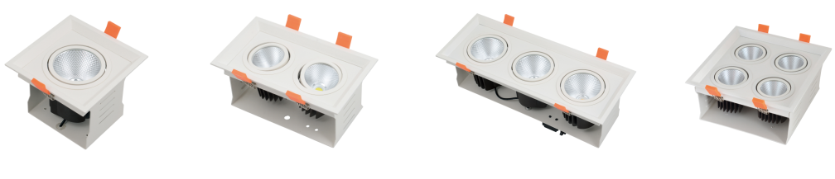

1. **Model No. GSD1201**

**Product Name: LED Grille Downlight 12W**

|  |  |  |  |  |  |  |  |  |  |  |
| --- | --- | --- | --- | --- | --- | --- | --- | --- | --- | --- |
| **Model No.** | **Power** | **Lumen(lm)** | **Driver Brand** | **LED Style** | **CCT(K)** | **Beam Angle** | **Power Factor** | **CRI** | **Size(mm)** | **Cutout(mm)** |
| GSD1201-1-A | 1*12W | 1000lm | Philips Driver | CREE | 3000K  4000K  5000K | 15°  24° | >0.90 | Ra80/90 | 133*132*110 | 120*120 |
| GSD1201-2-A | 2*12W | 2*1000lm | 232*132*110 | 220*120 |
| GSD1201-3-A | 3*12W | 3*1000lm | 240*132*110 | 330*120 |
| GSD1201-4-A | 4*12W | 4*1000lm | 232*232*110 | 225*225 |

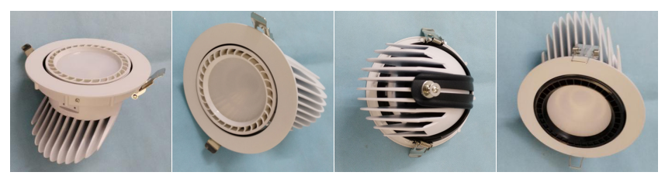

1. **Model No. SD005**

**Product Name: LED Trunk Downlight**

|  |  |  |  |  |  |  |  |  |  |  |
| --- | --- | --- | --- | --- | --- | --- | --- | --- | --- | --- |
| **Model No.** | **Power** | **Lumen(lm)** | **Driver Brand** | **LED Style** | **CCT(K)** | **Beam Angle** | **Power Factor** | **CRI** | **Size(mm)** | **Cutout(mm)** |
| SD005-2.5F | 10W | 850lm | Philips Driver | CREE | 3000K  4000K  5000K | 24°  38° | >0.90 | Ra80/90 | D90*H70 | D75 |
| SD005-3F | 15W | 1300lm | D115*H125 | D100 |
| SD005-4F | 25W | 2200lm | D138*H120 | D128 |
| SD005-5F | 35W | 2900lm | D165*H155 | D145 |
| SD005-6F | 40W | 350lm | D190*H165 | D175 |

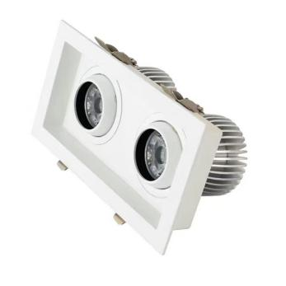

1. **Model No. ATD002-2**

**Product Name: Eyeball LED Downlight 2 Heads**

|  |  |  |  |  |  |  |  |  |  |  |
| --- | --- | --- | --- | --- | --- | --- | --- | --- | --- | --- |
| **Model No.** | **Power** | **Lumen(lm)** | **Driver Brand** | **LED Style** | **CCT(K)** | **Beam Angle** | **Power Factor** | **CRI** | **Size(mm)** | **Cutout(mm)** |
| ATD002-2-A | 2*12W | 2*1000lm | Philips Driver | CREE | 3000K  4000K  5000K | 15°  24°  38° | >0.90 | Ra80/90 | W115*L210*H95 | W95*L190 |
| ATD002-2-B | 2*20W | 2*1700lm | W135*L250*H120 | W115*L230 |
| ATD002-2-C | 2*30W | 2*2500lm | W135*L250*H130 | W115*L230 |

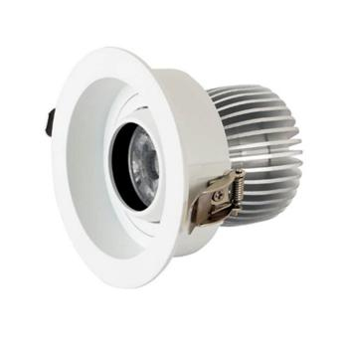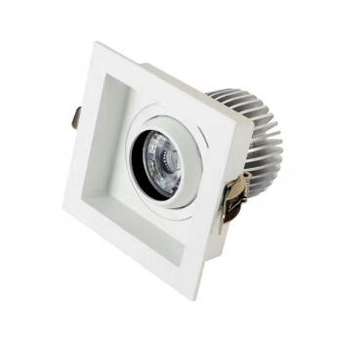

1. **Model No. ATD002**

**Product Name: Eyeball LED Downlight 1 Head**

|  |  |  |  |  |  |  |  |  |  |  |
| --- | --- | --- | --- | --- | --- | --- | --- | --- | --- | --- |
| **Model No.** | **Power** | **Lumen(lm)** | **Driver Brand** | **LED Style** | **CCT(K)** | **Beam Angle** | **Power Factor** | **CRI** | **Size(mm)** | **Cutout(mm)** |
| ATD002-3F | 12W | 1050lm | Philips Driver | CREE | 3000K  4000K  5000K | 15°  24°  40° | >0.90 | Ra80/90 | D115*H95 | D95 |
| ATD002-4F | 15W | 1300lm | D115*H105 | D95 |
| ATD002-5F | 20W | 1700lm | D135*H120 | D120 |
| ATD002-6F | 30W | 2600lm | D135*H130 | D120 |

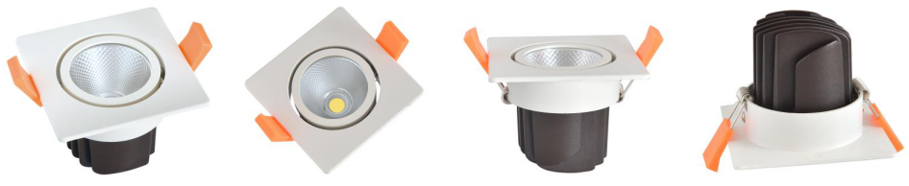

1. **Model No. TSD0806**

**Product Name: Square Adjustable LED Downlight 10W 15W 20W**

|  |  |  |  |  |  |  |  |  |  |  |
| --- | --- | --- | --- | --- | --- | --- | --- | --- | --- | --- |
| **Model No.** | **Power** | **Lumen(lm)** | **Driver Brand** | **LED Style** | **CCT(K)** | **Beam Angle** | **Power Factor** | **CRI** | **Size(mm)** | **Cutout(mm)** |
| TSD0806-A | 10W | 850lm | Philips Driver | CREE | 3000K 4000K 5000K | 24° | >0.90 | Ra80/90 | SQ85*H65 | D75 |
| TSD0806-B | 15W | 1300lm | SQ110*H85 | D95 |
| TSD0806-C | 20W | 1700lm | SQ145*H100 | D115 |

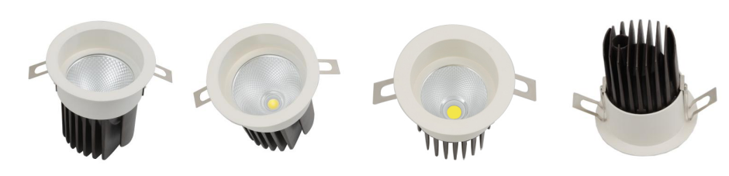

1. **Model No. TSD0803**

**Product Name: Round LED Spot Downlight**

|  |  |  |  |  |  |  |  |  |  |  |
| --- | --- | --- | --- | --- | --- | --- | --- | --- | --- | --- |
| **Model No.** | **Power** | **Lumen(lm)** | **Driver Brand** | **LED Style** | **CCT(K)** | **Beam Angle** | **Power Factor** | **CRI** | **Size(mm)** | **Cutout(mm)** |
| TSD0803-A | 10W | 850lm | Philips Driver | CREE | 3000K 4000K 5000K | 24° | >0.90 | Ra80/90 | D80*H90 | D75 |
| TSD0803-B | 15W | 1300lm | D100*H115 | D90 |
| TSD0803-C | 20W | 1700lm | D135*H145 | D115 |

欧为

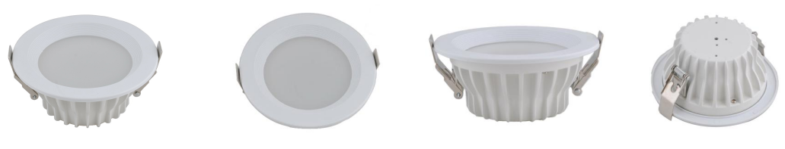

1. **Model No. TD036A**

**Product Name: SMD/COB LED Downlight**

|  |  |  |  |  |  |  |  |  |  |  |
| --- | --- | --- | --- | --- | --- | --- | --- | --- | --- | --- |
| **​Model No.** | **Power** | **Lumen(lm)** | **Driver Brand** | **LED Style** | **CCT(K)** | **Beam Angle** | **Power Factor** | **CRI** | **Size(mm)** | **Cutout(mm)** |
| TD036A-5F | 10W | 850lm | Philips Driver | SMD | 3000K  4000K  6000K | 100° | >0.90 | Ra80 | D145*H63 | D125 |
| TD036A-6F | 20W | 1700lm | D196*H63 | D170 |
| TD036A-8F | 30W | 2500lm | D242*H63 | D210 |

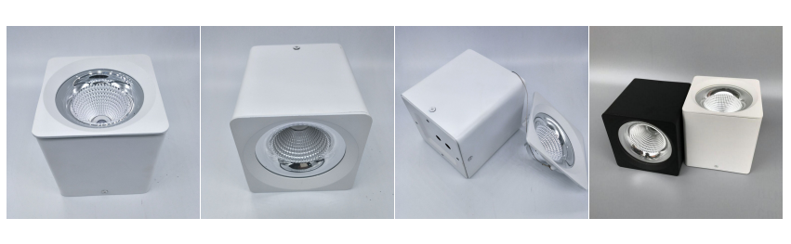

1. **Model No. SMDL001**

**Product Name: Square Surface Mounted Downlight**

|  |  |  |  |  |  |  |  |  |  |  |
| --- | --- | --- | --- | --- | --- | --- | --- | --- | --- | --- |
| **Model No.** | **Power** | **Lumen(lm)** | **Driver Brand** | **LED Style** | **CCT(K)** | **Beam Angle** | **Power Factor** | **CRI** | **Size(mm)** | **Height(mm)** |
| SMDL002-4F | 9W | 750lm | Philips Driver | CREE | 3000K  4000K  5000K | 24°45° | >0.90 | Ra80/90 | 90*90 | 90 |
| SMDL002-5F | 15W | 1300lm | 110*110 | 120 |
| SMDL002-6F | 30W | 2500lm | 130*130 | 135 |
| SMDL002-8F | 40W | 3300lm | 160*160 | 165 |